**Software Requirements**

**Specification**

**for**

**Dash-R-Come**

**Version 1.0 approved**

**Prepared by**

**Evangelista, Hurley John M.**

**Devera, Emmanuel S.**

**Fernandez, Alyssa.**

**Matawaran, Miguel Enrico.**

**CSIT01**

**March 28, 2018**

# Table of Contents

1. Introduction 2

1.1 Purpose 3

1.2 Document Conventions 3

Convention 3

Description 3

Bold text 3

Emphasizes item for particular importance 3

Bigger font size 3

Title of particular item 3

Code 3

Text that represent programming code 3

1.3 Intended Audience and Reading Suggestions 3

1.4 Product Scope 3

1.5 References 3

2. Overall Description 3

2.1 Product Perspective 4

2.2 Product Functions 4

2.3 User Classes and Characteristics 4

2.4 Operating Environment 4

2.5 Design and Implementation Constraints 4

2.6 User Documentation 5

Which devices does the mobile app support? 5

Basic Steps for Users 5

2.7 Assumptions and Dependencies 11

3. External Interface Requirements 11

3.1 User Interfaces 11

3.1.1 Home Screen 11

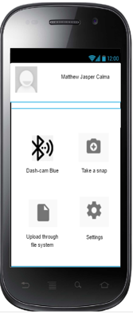 11

3.2 Hardware Interfaces 11

3.3 Software Interfaces 11

3.4 Communication Interfaces 12

Dash-R-Come is connected to the Google Drive using HTTPS (hypertext transfer protocol secure) on the port 443. The google mail account can download, delete and share the picture or video on the google drive. 12

3.4 Safety Requirements 12

3.5 Security Requirements 12

To ensure the integrity of the report of the users. Firebase used https protocol and hash to make sure the file is readable, trusted and retrievable. 12

3.6 Software Quality Attributes 12

3.7 Business Rules 12

4. Main Features 13

4.1 System Feature 1: Capture an incident 13

4.2 System Feature 2: Hotline List 13

4.3 System Feature 3: Upload through File System 13

4.4 System Feature 4: Video Trimmer 14

5.1 Performance Requirements 14

# Introduction

## Purpose

The purpose of the project is to provide the client a system that could help them get a detailed incident report and real events. Also, to provide the client an updated record of incidents that could be used in crime statistics purposes.

## Document Conventions

|  |  |
| --- | --- |
| Convention | Description |
| Bold text | Emphasizes item for particular importance |
| Bigger font size | Title of particular item |
| Code | Text that represent programming code |

## 1.3 Intended Audience and Reading Suggestions

The project manager, developer, and analysts are the group of people working to create the system. It is crucial for the group to know the most commonly incidents in the Barangay Magallanes. The users and employees, in addition, need to understand the how to use the system created by the group. The importance of parts of the document, however, is the introduction, results and implementation.

## 1.4 Product Scope

The scope of the project encompasses all kind of incident, such as; crime, robbery, traffic or road incident, fire incident, etc. For now, the project is limited to the Cities of Makati. The group target users of the mobile application are the motorists, bystanders, constituents and android device users. For the user to use the mobile application, the user must register to the mobile application and must have an internet connection or mobile data. Also, the user must have a picture or video footage of the incident captured that will be uploaded later to the web server, which is being operated by Barangay Magallanes employee. In capturing pictures or videos of an incident, the user can use a dashboard camera or any android device, if the user used a dashboard camera, the user has to transfer the “memory SD card” of the dashboard camera to the android device to save the video. The mobile application provides 4 main features that is based on the client’s problem, the main features are the following; “Capture an Incident, Upload from File System, List of Hotlines, and Video Trimmer”.

## 1.5 References

Evidence handling is important to have solid proof to a certain incident (Sec. Rogelio Singson, 2017)

Always eager to serve if it means doing the job themselves (Francis Tolentino, 2017)

# Overall Description

The proposed project is an incident reporting system, the project encompasses all kind of incident, such as; crime, robbery, traffic or road incident, fire incident, etc. The system enables the user to send any incident using their android device.

The team aims to help Barangay Magallanes and other Local Government Unit expand their services in terms of receiving incident reports or complaints. Barangay Magallanes receives incident reports and complaints through their hotline. The problem in their current system, according to Police Chief Inspector Samuel Melchor Fernandez and Mr. Jesus Sumandal, one of the desk officers of Barangay Magallanes, is that the agency cannot verify if the report is real. Using the proposed system, Barangay Magallanes will be able to verify if the report is true, also, they will receive a detailed incident report which could help them locate the location easily.

## Product Perspective

The system is an additional system for the Barangay Magallanes and other Local Government Unit in the Cities of Makati, in handling incident reports. The proposed system will store the video or picture of the incident to the system.

## Product Functions

* Web server or Google Cloud Storage to store the incident video or picture that has been captured.
* Login system feature to authenticate the user and to avoid fake reporters.
* 'Take a snap' feature that allows user to send only a picture of an event.
* DashCamBlue feature that allows user to transfer the video footage of the incident from the dashboard camera to the android device.
* 30 seconds limitation for capturing to video footage to reduce the memory used.

## User Classes and Characteristics

The employee of the Barangay Magallanes will be responsible to monitor the web server or google cloud storage. The employee must generate a report if the video or picture that have been captured with a description details is valid to the classification of incidents. If it is valid, the employee will take an immediate action for the incident. Whenever the incident is not on the Magallanes Makati. The employee can call or contact the other agency for help.

## Operating Environment

The system is only accessible in Barangay Magallanes. The system will be manned by Barangay Magallanes Employee. The Barangay Magallanes Employee is responsible for analyzing, categorizing and validating the incident report.

## Design and Implementation Constraints

The Barangay Magallanes claimed that the internet connection is stable, computer is handled by their employers and employees are working 24/7. It would be difficult for the group to only store the data on its web server that is why the group decided to go to the Google cloud storage. So that, it can be accessed all the time.

## User Documentation

**Overview**

The mobile application has functions that will enable each user to send the incident that they encounter. A brief description is optional.

## Which devices does the mobile app support?

You can install the given application on any mobile devices that have Android operating systems.

## Basic Steps for Users

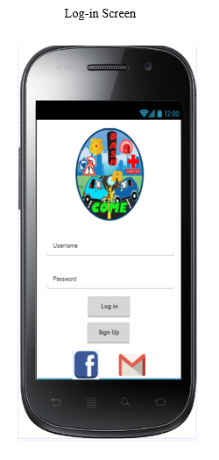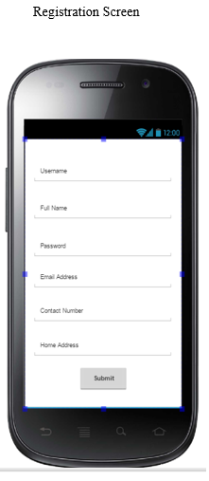

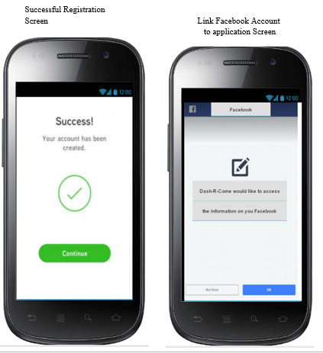

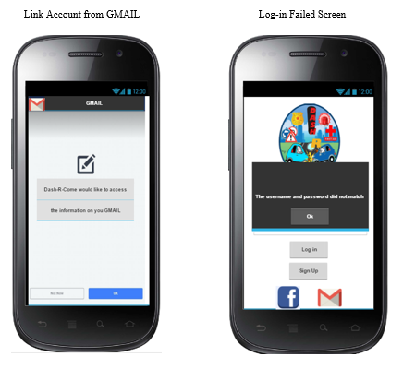

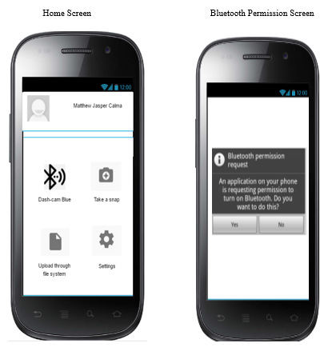

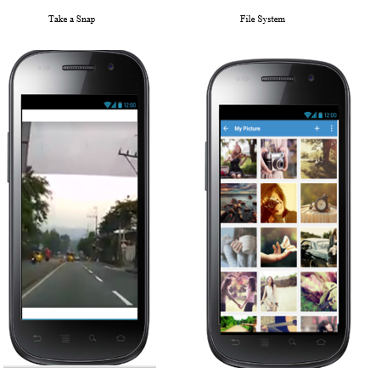

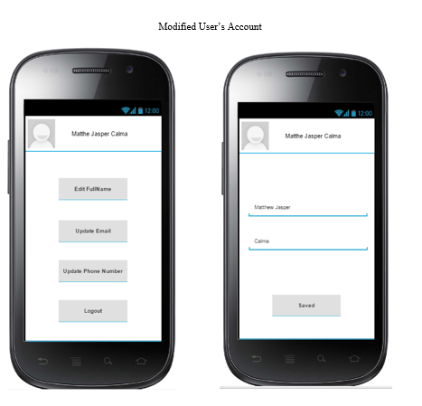

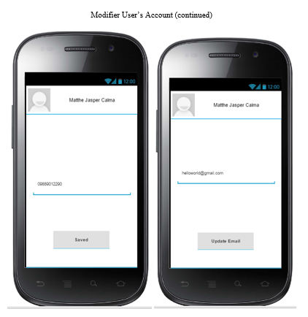

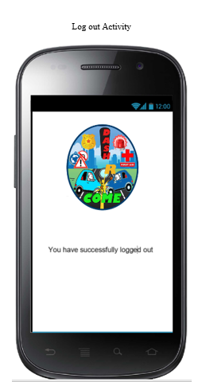

## 2.7 Assumptions and Dependencies

The department heads don’t need to assign an employee for the ticket created by the front desk. The system will automatically send the generated ticket to the employees working on a particular shift.

# External Interface Requirements

## User Interfaces

## Home Screen

## 

## Hardware Interfaces

Dash-R-Come is a mobile application intended to be installed on an Android smartphone. The mobile application will be supported by the Google Cloud Storage and node PC of Barangay Magallanes. The node PC will be also the storage of the registration of the users' information.

## Software Interfaces

Dash-R-Come mobile application is being developed using Android Studio which can be installed in a mobile device. Integrated with Google Cloud Platform.

# 3.4 Communication Interfaces

# Dash-R-Come is connected to the Google Drive using HTTPS (hypertext transfer protocol secure) on the port 443. The google mail account can download, delete and share the picture or video on the google drive.

## Safety Requirements

|  |  |
| --- | --- |
| Safety Sub factor | Safety Requirement |
| User data protection | The data that users are providing must not leak or displayed in public |
| Safety Incident Reporting | The Incident Management System shall ask for the details of the incident to avoid prank reports |

## Security Requirements

## To ensure the integrity of the report of the users. Firebase used https protocol and hash to make sure the file is readable, trusted and retrievable.

## Software Quality Attributes

* Correctness – Agreement of the program code to specifications
* Reliability – Availability of the software
* Learnability – The UI of the system is user-friendly
* Maintainability – The project is easy to maintain because it does not require any hardware or software other than the database, computer units and internet connection.
* Readability – The project has complement documentation including the diagrams
* Extensibility – The group has future plans to upgrade the project once implemented
* Efficiency – The database that the system is using is cheap, it would be easy to upgrade the database if storage is needed

## Business Rules

* The user can send one or many incident reports
* Only the on-duty personnel can operate the web-server
* The user may or may not have an account
* The user must verify the email address if he/she choose to register
* Different agencies can respond to the incident
* The user can be a registered user or a guest user

# 4. Main Features

## 4.1 System Feature 1: Capture an incident

### 4.1.1 Description and Priority

### High Priority

### 4.1.2 Stimulus/Response Sequences

### Step 1: Login to the mobile application

### Step 2: On the home activity click the camera icon and the application will open the video camera.

### 

### 4.1.3 Functional Requirements

### An incident can be filmed using this feature.

## 4.2 System Feature 2: Hotline List

### 4.2.1 Description and Priority

### High Priority

### 4.2.2Stimulus/Response Sequences

## 

### Step 1: Login to the mobile application.

### Step 2: On the home activity click the hotline icon and application will show you the list of contacts of agencies in Makati.

### 

4.2.3 Functional Requirements

To capture an incident if something’s happened. A picture or video will be a good primary source of evidence.

## 4.3 System Feature 3: Upload through File System

## 

### 4.3.1 Description and Priority

### High Priority

### 4.3.2 Stimulus/Response Sequences

## 

### Step1: Login to the mobile application

### Step 2: On the home activity click the gallery icon and application will redirect you to the gallery to send to the web server.

4.3.3 Functional Requirements

To have the reports analysis, the system should be connected to the internet and also the user should have internet connection in order to send the file.

## 4.4 System Feature 4: Video Trimmer

### 4.4.1 Description and Priority

### High Priority

### 4.4.2Stimulus/Response Sequences

## 

### Step 1: Login to the mobile application.

### Step 2: On the home activity click the scissors icon and application will redirect you to the video cutter site.

### 

4.4.3 Functional Requirements

To reduce the file size when uploading, the user can trim the video

**5. Other Nonfunctional Requirements**

* Authentication Service
* Communication Channels
* Storage Capacity
* Web storage clerk/ Barangay Magallanes employee
* Availability – online and offline database

## 5.1 Performance Requirements

* The system must be online 24/7 for 365 days in one calendar year
* Upon submitting for a new account profile, it shall take 3 seconds to confirm the Gmail verification request.
* The system database shall accommodate 500 to 1000 users.
* For the client to play the video in clear and standard definition, 1.5 mbps to 3mbps

# 